Legend
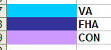

The following excel spreadsheet foreclosure tracking board 2014.xls, illustrates actions that need to be taken after we foreclose.

VA

*1st legal: date that attorneys posted at the courthouse prior to foreclosure, this info resides in MS
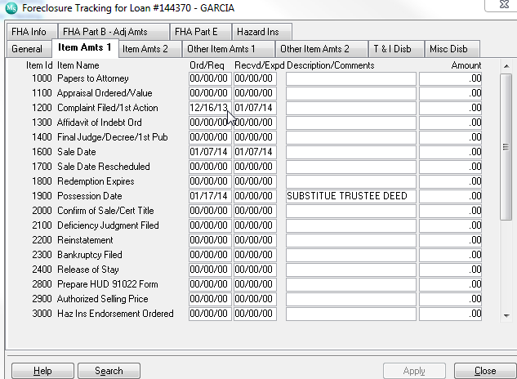
Metric: pick duedate and 1st legal needs to come in 5 months after due date if this is not the case we need to change color or provide an alert that first legal is beyond due date

*UPB:Unpaid Principal Balance, if foreclosre not final we pick the info from the ‘current principal balance” if paid off or foreclosed then we pick amount from “principal paid”

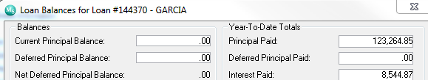

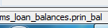
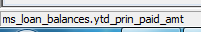

*F/C DATE
Date Foreclosed
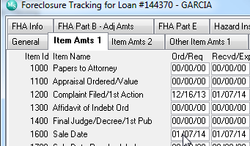
Line 1600 sale date ord/req
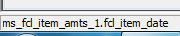

*RESULTS OF SALE : NOTIFICATION THRU VALERIE OF FORECLOSURE SALE RESULTS.
METRIC NEEDS TO BE DONE WITHIN 24 HOURS OF FORECLOSURE DATE
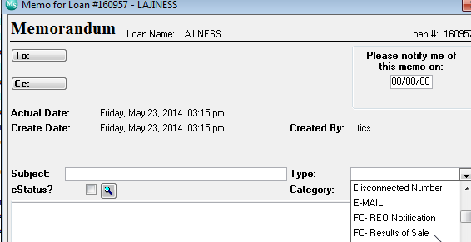

Info comes from memo type fc- reo notification, this is a date field , please populate create date
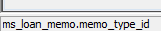

* Transfer of Custody (15 Days from Sale): when RMMC conveys property to VA
Metric it needs to be done within 15 days of sale, serv will need to be notified via email and color 7 days prior to those 15 days
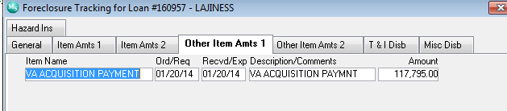
This is a date field ord/req please ensure “va acquisition payment’ is the descption

*VA Acquisition Payment Date:
Now this is the rec/exp another date field

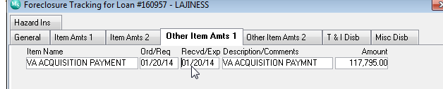

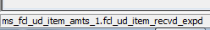

*VA Acquisition Payment Amount:
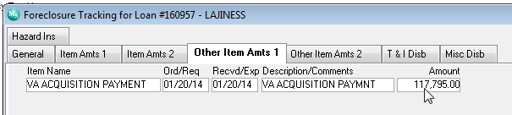
This is a numeric field amount

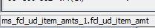

*VA Basic Claim Date:

Date when we submit a claim for loss to VA

Metric: 45 days of foreclure date

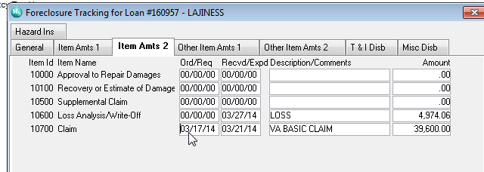
field 10700 claim , ord/req

*VA Summary of Claim Date: when claim is received date

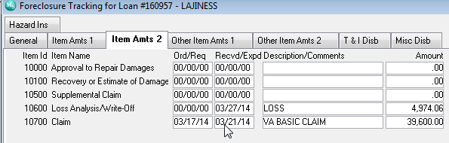
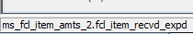 this is a date field again 10700 , recv/expd

*VA Claim Amount

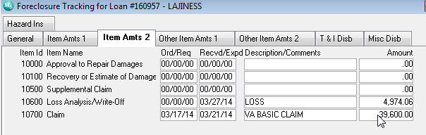
Again line 10700 amount , numeric



